R Notebook
BIS 581
###Data Preparation Steps prior to analysis###

loading libraries

Loading the data sets into R
VDI <- read.csv("vdi_serverlogs.csv", header=TRUE, stringsAsFactors = FALSE)
apps <- read.csv("vdi_statsapps.csv", header=TRUE, stringsAsFactors = FALSE)

Joinging the two data sets together
apps$VDI_ID <- as.integer(apps$VDI_ID)
## Warning: NAs introduced by coercion
usage <- VDI %>% inner_join(apps)
## Joining with `by = join_by(VDI_ID)`

Fixing the date format and converting date columns
Since we need to filter for “year 2015”, we first need to convert the date columns in our new “usage” dataset so we can identify which records are from 2015. By running the code chunk below, we can change the date data in the usage dataset. Now the logon_DTS column becomes a proper date-time column. The logon_date column extracts just the date part (for daily usage analysis) and the logon_year column extracts just the year (so we can filter for 2015). We can see the dates are now properly formatted as “2011-04-15” whereas in the raw data set the dates were in the format “4/15/11” where the year was only listed as 11 instead of 2011. If we did not filter this then R would interpret it as the year 11 AD instead of 2011 AD.
# Converting the date columns in the USAGE dataset
usage <- usage %>%
mutate(
logon_DTS = as.POSIXct(logon_DTS, format = "%m/%d/%y %H:%M"),
logon_date = as.Date(logon_DTS),
logon_year = format(logon_date, "%Y")
)

Checking the years in our dataset and looking at the record for 2015
After running the code below we found out that we have 299,998 records from 2015. So we can proceed with the 2015 analysis as required.
year_summary <- usage %>%
count(logon_year) %>%
arrange(logon_year)
print(year_summary)
## logon_year n
## 1 2011 192744
## 2 2012 790386
## 3 2013 946018
## 4 2014 952924
## 5 2015 299998
## 6 2016 19

Applying necessary filters
# Applying the required filters
usage_2015_vdi <- usage %>%
filter(logon_year == "2015",
startsWith(comp_name, "CMU"))
# Taking a look at the data set after filtering
cat("Total records after filtering:", nrow(usage_2015_vdi), "\n")
## Total records after filtering: 227386
cat("Unique users in filtered data:", n_distinct(usage_2015_vdi$userid), "\n")
## Unique users in filtered data: 3013
cat("Date range:", as.character(min(usage_2015_vdi$logon_date)), "to",
as.character(max(usage_2015_vdi$logon_date)), "\n")
## Date range: 2015-01-07 to 2015-08-28
#Adressing duplicate user IDs
To ensure accurate user counts, I used n_distinct(userid) which correctly counts unique users regardless of how many applications they used during their session. I will not do any filtering for duplicate user IDs because for user counts we can use the function n_distinct to avoid any errors with user ID counts. The issue here is that after a user logs into a session he or she may use different applications which results in duplicate entries for username, login and logout time. But the entries are all necessary and should not be filtered out because they are needed to analyze the usage of the applications. Although the user ID, and login and logout times for the machines are the same the apps are different and the start and stop time of the apps are also necessary to understand how long each apps are being used. So we should be careful with our filters and apply relevant filters where they are needed. The goal of applying filters in our data is to make our analysis easier, not to just make the data set shorter so that we can finish our work quickly.
#Data quality check
After filtering our data set according to our requirements which are: 1. The year 2015 2. For VDI Machines only
We did a quality check on our filtered data set So that We can dive into our analysis. After checking the data quality, our key findings are:
The negatives:
- 15.97% of application sessions are incomplete (36,319 records with “1900-01-01” stop times). This means we cannot calculate accurate application usage duration for these records and could affect any analysis of application usage. Unrealistic values mean poor data quality.
- CPU data shows no missing values but contains negative values. CPU usage is shown as percentage and can never have a negative value. So this will affect our Average CPU Usage analysis. Once again while there are no missing values, the data quality is poor due to unrealistic negative values.
- No data for the fall semester. The data set covers January to August but there is no data for the remainder of the year.
The Positives:
- High user engagement variation was observed with an average of 15 sessions per user. The highest number of sessions by a single user was 348 which means one single user had 348 separate VDI sessions during the 2015 period. There were 555 users (18.4% of total) who had only one session.
- No missing values in any columns.
- No sessions with logout time before login. Otherwise that would be another major quality issue.
- Good data coverage from January to August 2015.
# 1. Checking for missing values
cat("1. MISSING VALUES ANALYSIS: No Missing Values\n")
## 1. MISSING VALUES ANALYSIS: No Missing Values
missing_summary <- data.frame(
Column = names(usage_2015_vdi),
Missing_Count = colSums(is.na(usage_2015_vdi)),
Missing_Percentage = round(colSums(is.na(usage_2015_vdi)) / nrow(usage_2015_vdi) * 100, 2)
)
print(missing_summary)
## Column Missing_Count Missing_Percentage
## VDI_ID VDI_ID 0 0
## comp_name comp_name 0 0
## userid userid 0 0
## logon_DTS logon_DTS 0 0
## logout_DTS logout_DTS 0 0
## connection_server connection_server 0 0
## remote_ip remote_ip 0 0
## remote_od remote_od 0 0
## avg_cpu avg_cpu 0 0
## app_id app_id 0 0
## app_name app_name 0 0
## start start 0 0
## stop stop 0 0
## logon_date logon_date 0 0
## logon_year logon_year 0 0
cat("\n")
# 2. Checking for duplicate application records within sessions
cat("2. DUPLICATE RECORDS ANALYSIS:\n")
## 2. DUPLICATE RECORDS ANALYSIS:
total_records <- nrow(usage_2015_vdi)
unique_sessions <- n_distinct(usage_2015_vdi$VDI_ID)
cat("Total records:", total_records, "\n")
## Total records: 227386
cat("Unique VDI sessions:", unique_sessions, "\n")
## Unique VDI sessions: 45209
cat("Average applications per session:", round(total_records / unique_sessions, 2), "\n")
## Average applications per session: 5.03
cat("\n")
# 3. Checking date ranges and validity
cat("3. DATE VALIDITY CHECK:\n")
## 3. DATE VALIDITY CHECK:
cat("Logon date range:", as.character(min(usage_2015_vdi$logon_date)), "to",
as.character(max(usage_2015_vdi$logon_date)), "\n")
## Logon date range: 2015-01-07 to 2015-08-28
# Checking for illogical dates (logout before logon)
invalid_sessions <- usage_2015_vdi %>%
mutate(logout_DTS = as.POSIXct(logout_DTS, format = "%m/%d/%y %H:%M")) %>%
filter(logout_DTS < logon_DTS) %>%
nrow()
cat("Sessions with logout before logon:", invalid_sessions, "\n")
## Sessions with logout before logon: 0
# 4. Checking application stop times for "1900-01-01" placeholders
cat("4. SESSIONS WITH WRONG STOP TIMES:\n")
## 4. SESSIONS WITH WRONG STOP TIMES:
incomplete_app_sessions <- sum(usage_2015_vdi$stop == "1900-01-01 00:00:00", na.rm = TRUE)
cat("Application sessions with '1900-01-01' stop time (incomplete):", incomplete_app_sessions, "\n")
## Application sessions with '1900-01-01' stop time (incomplete): 36319
cat("Percentage of incomplete app sessions:", round(incomplete_app_sessions / nrow(usage_2015_vdi) * 100, 2), "%\n")
## Percentage of incomplete app sessions: 15.97 %
cat("\n")
# 5. Checking CPU data availability
cat("5. CPU DATA AVAILABILITY:\n")
## 5. CPU DATA AVAILABILITY:
cpu_records_with_data <- sum(!is.na(usage_2015_vdi$avg_cpu))
cat("Records with CPU data:", cpu_records_with_data, "/", nrow(usage_2015_vdi), "\n")
## Records with CPU data: 227386 / 227386
cat("Percentage with CPU data:", round(cpu_records_with_data / nrow(usage_2015_vdi) * 100, 2), "%\n")
## Percentage with CPU data: 100 %
# 6. Checking for negative CPU values
negative_cpu_records <- sum(usage_2015_vdi$avg_cpu < 0, na.rm = TRUE)
cat("Records with negative CPU values:", negative_cpu_records, "/", cpu_records_with_data, "\n")
## Records with negative CPU values: 13371 / 227386
cat("Percentage of CPU data that is negative:", round(negative_cpu_records / cpu_records_with_data * 100, 2), "%\n")
## Percentage of CPU data that is negative: 5.88 %

Question 1- How many users were in the system in total?
The total number of users in the system in the year 2015 was 3013. Since I was provided with a tip to pay attention to distinction of a user being logged in versus a user launching and using different applications within the session, in this question I counted the total number of users in the year 2015 but I also provided some extra insight about the usage of different apps. The following code chunk provides us with a bar chart that shows both the total number of users in the system as well as the frequency of application usage for different applications. We created the bar chart by using the top 10 apps based on the count frequency of the apps.
# Finding total number of users
total_users <- n_distinct(usage_2015_vdi$userid)
cat("Total unique users on VDI system in 2015:", total_users, "\n\n")
## Total unique users on VDI system in 2015: 3013
# Calculate top applications by usage frequency (not unique users)
top_apps_by_usage <- usage_2015_vdi %>%
count(app_name, sort = TRUE) %>%
head(10) # Top 6 most frequently used applications
# Create the comparison data
comparison_data <- bind_rows(
data.frame(
category = "TOTAL NUMBER OF USERS",
count = total_users,
type = "Total Users"
),
top_apps_by_usage %>%
mutate(
category = toupper(app_name),
count = n,
type = "Application Usage frequency"
) %>%
select(category, count, type)
)
# Creating a visualization for number of users
ggplot(comparison_data, aes(x = reorder(category, count), y = count, fill = type)) +
geom_col(alpha = 0.8) +
geom_text(aes(label = scales::comma(count)),
hjust = -0.1, size = 4, color = "black", fontface = "bold") +
coord_flip() +
scale_fill_manual(values = c("Total Users" = "blue4", "Application Usage frequency" = "pink3")) +
labs(
title = "Total Number of Users vs Most Used Applications",
x = NULL,
y = "Count",
fill = "Metric Type",
) +
theme_minimal() +
theme(
plot.title = element_text(face = "bold", size = 14, hjust = 0.5),
plot.subtitle = element_text(color = "gray40", size = 11, hjust = 0.5),
plot.caption = element_text(color = "red", size = 8),
legend.position = "top",
axis.text.y = element_text(size = 10, face = "bold")
) +
scale_y_continuous(expand = expansion(mult = c(0, 0.15)))
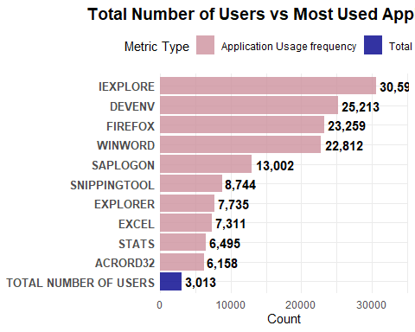

Question 2- What is the average number of users per day?
This question seemed a little vague to me since I couldn’t properly understand what per day meant here. Does it mean per day of the week like average users on sunday or monday or does it mean average users per day as in average number of users everyday. So I calculated both.
At first, I calculated the number of unique users per day first.Then I calculated the average users per day. The average number of users per day is 139. But the Median is 62. This difference between the average and the median is explained better when we look at the visualization. Very few students take summer classes which leads to a massive decrease in the usage of the VDI system or any other school resources in general. We can clearly see that during the Summer beginning from mid-May until the end of August the number of users has always been below 100 which is lower than the average number of users from January to August which is 139. So there is a massive fluctuation in the number of users during regular school semester and during the summer.
Finally, as a bonus I calculated the average number of users per day based on each day of the week. This means the average number of users on Sunday or Monday or any other day of the week. We can see from the bar chart that Tuesday is the peak usage day with an average of 191 users. The weekends are obviously the slowest days with more than 50% less usage when compared to the weekdays. Another observation is that there is a massive decline on Fridays which is just before the weekend. So basically heavy traffic on every weekday and then a decline on Friday leading to low traffic on Saturday and Sunday.
# Calculating unique users per day
daily_users <- usage_2015_vdi %>%
distinct(logon_date, userid) %>%
group_by(logon_date) %>%
summarise(daily_unique_users = n()) %>%
arrange(logon_date)
# Calculating the average
avg_users_per_day <- round(mean(daily_users$daily_unique_users))
# Editing the code by rounding the results in the summary after running the code once
daily_summary <- daily_users %>%
summarise(
min_users = min(daily_unique_users),
max_users = max(daily_unique_users),
median_users = median(daily_unique_users),
avg_users = round(mean(daily_unique_users)),
total_days = n()
)
#Showing the results
print(daily_summary)
## # A tibble: 1 × 5
## min_users max_users median_users avg_users total_days
## <int> <int> <int> <dbl> <int>
## 1 4 540 62 139 223
# Providing Visualization
time_series_analysis <- ggplot(daily_users, aes(x = logon_date, y = daily_unique_users)) +
geom_line(color = "#2E86AB", size = 0.8, alpha = 0.8) +
geom_point(color = "#2E86AB", size = 1, alpha = 0.6) +
geom_hline(yintercept = avg_users_per_day, linetype = "solid", color = "black", size = 1) +
# FIXED: Using annotate() instead of geom_text() for single labels
annotate("text", x = min(daily_users$logon_date), y = avg_users_per_day,
label = paste("Average:", avg_users_per_day, "users/day"),
hjust = 0, vjust = -0.5, color = "black", fontface = "bold", size = 4) +
labs(
title = "Number of Daily Users in 2015",
subtitle = "Daily fluctuation and average usage pattern",
x = "Date",
y = "Number of Unique Users"
) +
theme_minimal() +
theme(
plot.title = element_text(face = "bold", size = 14, hjust = 0.5),
plot.subtitle = element_text(color = "gray40", size = 11, hjust = 0.5)
) +
# Fix x-axis: Show all months
scale_x_date(
date_breaks = "1 month",
date_labels = "%b"
) +
# Fix y-axis: Show breaks every 100 from 0 to 600
scale_y_continuous(
breaks = seq(0, 600, by = 100),
limits = c(0, 600)
)
## Warning: Using `size` aesthetic for lines was deprecated in ggplot2 3.4.0.
## ℹ Please use `linewidth` instead.
## This warning is displayed once every 8 hours.
## Call `lifecycle::last_lifecycle_warnings()` to see where this warning was
## generated.
print(time_series_analysis)
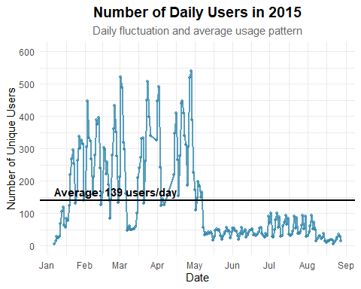
# Calculating average users per day according to day of the week
daily_users %>%
mutate(day_of_week = weekdays(logon_date)) %>%
group_by(day_of_week) %>%
summarise(avg_users = round(mean(daily_unique_users))) %>%
arrange(desc(avg_users)) %>%
print()
## # A tibble: 7 × 2
## day_of_week avg_users
## <chr> <dbl>
## 1 Tuesday 191
## 2 Thursday 169
## 3 Wednesday 169
## 4 Monday 157
## 5 Friday 117
## 6 Sunday 97
## 7 Saturday 67
# Creating a Day of the Week Average Users Visualization
day_of_week_avg <- daily_users %>%
mutate(day_of_week = weekdays(logon_date)) %>%
group_by(day_of_week) %>%
summarise(avg_users = round(mean(daily_unique_users)))
# Ordering days properly (instead of alphabetical)
day_levels <- c("Monday", "Tuesday", "Wednesday", "Thursday", "Friday", "Saturday", "Sunday")
day_of_week_avg$day_of_week <- factor(day_of_week_avg$day_of_week, levels = day_levels)
# Creating the bar chart
ggplot(day_of_week_avg, aes(x = day_of_week, y = avg_users)) +
geom_col(fill = "#2E86AB", alpha = 0.8) +
geom_text(aes(label = paste(avg_users, "users")),
vjust = -0.5, color = "#2E86AB", fontface = "bold", size = 4) +
labs(
title = "Average VDI Users by Day of Week - 2015",
subtitle = "Tuesday is the busiest day; weekends show significantly lower usage",
x = "Day of Week",
y = "Average Number of Users"
) +
theme_minimal() +
theme(
plot.title = element_text(face = "bold", size = 14, hjust = 0.5),
plot.subtitle = element_text(color = "gray40", size = 11, hjust = 0.5),
axis.text.x = element_text(size = 10)
) +
scale_y_continuous(expand = expansion(mult = c(0, 0.1)), limits = c(0, 220))
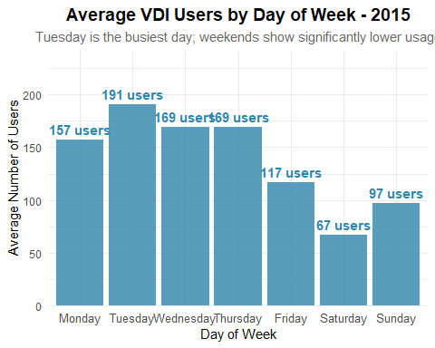

Question 3- What is the highest number of users per day?
Once again for this question, just like the previous one I calculated the highest number of users in a day among all the total days available in the data set which is 223 days. So the highest number of users per day is 540 which was recorded on April 28(Tuesday ).
Afterwards, I also calculated the highest number of users on every day of the week like Sunday or Monday and I provided a visualization for it as well. The bar chart shows resemblance to the previous bar chart that showed average number of users on each day of the week.
As a bonus I also provided another visualization after calculating the top 10 busiest days and sorting them according to both the dates and the days of the week. We can observe from this graph that The Mondays and Tuesdays are the busiest since among the top 10 busiest days 5 were Tuesdays and 3 were Mondays. The remaining two were a Wednesday and a Thursday.
# Calculating unique users per day (data preparation)
daily_users <- usage_2015_vdi %>%
distinct(logon_date, userid) %>%
group_by(logon_date) %>%
summarise(daily_unique_users = n()) %>%
arrange(logon_date)
#Showing the results
print(daily_summary)
## # A tibble: 1 × 5
## min_users max_users median_users avg_users total_days
## <int> <int> <int> <dbl> <int>
## 1 4 540 62 139 223
# Calculating maximum users for each day of week
max_by_dow <- daily_users %>%
mutate(day_of_week = weekdays(logon_date)) %>%
group_by(day_of_week) %>%
summarise(max_users = max(daily_unique_users)) %>%
arrange(desc(max_users))
print(max_by_dow)
## # A tibble: 7 × 2
## day_of_week max_users
## <chr> <int>
## 1 Tuesday 540
## 2 Monday 522
## 3 Thursday 491
## 4 Wednesday 447
## 5 Friday 334
## 6 Sunday 306
## 7 Saturday 186
# Order days properly
dow_levels <- c("Monday", "Tuesday", "Wednesday", "Thursday", "Friday", "Saturday", "Sunday")
max_by_dow$day_of_week <- factor(max_by_dow$day_of_week, levels = dow_levels)
# Create bar chart
ggplot(max_by_dow, aes(x = day_of_week, y = max_users)) +
geom_col(fill = "#A23B72", alpha = 0.8) +
geom_text(aes(label = paste(max_users, "users")),
vjust = -0.5, color = "#A23B72", fontface = "bold", size = 4) +
labs(
title = "Highest Number of Users recorded on each day of the Week in 2015",
x = "Day of Week",
y = "Maximum Number of Users"
) +
theme_minimal() +
theme(
plot.title = element_text(face = "bold", size = 14, hjust = 0.5),
plot.subtitle = element_text(color = "gray40", size = 11, hjust = 0.5),
axis.text.x = element_text(size = 10)
) +
scale_y_continuous(expand = expansion(mult = c(0, 0.1)), limits = c(0, 600))
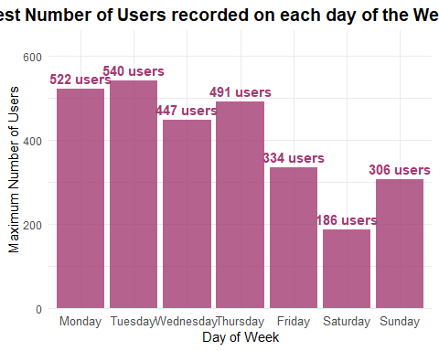
# Bonus Insight: Geting the top 10 busiest days with both date and day of the week
top_days <- daily_users %>%
arrange(desc(daily_unique_users)) %>%
head(10) %>%
mutate(
day_of_week = weekdays(logon_date),
date_with_dow = paste(format(logon_date, "%B %d"), " (", day_of_week, ")", sep = "")
)
print(top_days %>% select(logon_date, day_of_week, daily_unique_users))
## # A tibble: 10 × 3
## logon_date day_of_week daily_unique_users
## <date> <chr> <int>
## 1 2015-04-28 Tuesday 540
## 2 2015-03-02 Monday 522
## 3 2015-04-27 Monday 519
## 4 2015-03-24 Tuesday 507
## 5 2015-04-02 Thursday 491
## 6 2015-03-03 Tuesday 488
## 7 2015-03-23 Monday 450
## 8 2015-04-21 Tuesday 448
## 9 2015-04-01 Wednesday 447
## 10 2015-02-03 Tuesday 446
# Creating the visualization
ggplot(top_days, aes(x = reorder(date_with_dow, daily_unique_users), y = daily_unique_users)) +
geom_col(fill = "#A23B72", alpha = 0.8) +
geom_text(aes(label = paste(daily_unique_users, "users")),
hjust = -0.1, color = "#A23B72", fontface = "bold", size = 4) +
coord_flip() +
labs(
title = "Top 10 Busiest days in 2015",
subtitle = "Peak usage days showing both date and day of the week",
x = "Date (Day of Week)",
y = "Number of Unique Users"
) +
theme_minimal() +
theme(
plot.title = element_text(face = "bold", size = 14, hjust = 0.5),
plot.subtitle = element_text(color = "gray40", size = 11, hjust = 0.5),
axis.text.y = element_text(size = 10)
) +
scale_y_continuous(expand = expansion(mult = c(0, 0.15)), limits = c(0, 600))
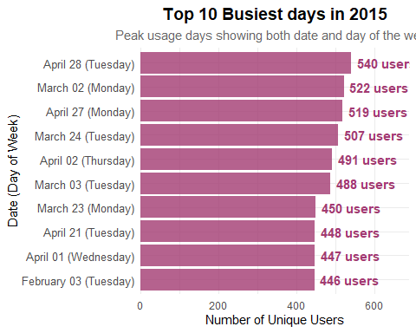

Specific Additional Question (My Last name is Shams which starts with an “S”)
#top 5 users by length of time logged in, average CPU usage for those users

Part 1- The top 5 users by length of time logged in
For the first part of this question which is determining the top 5 users by length of time logged in. For this we need to convert the logout dates just how converted the login dates.Because to find the duration of sessions we need both the login and the logout time. The summary of the top 5 users are:
userid18508: 1,261 hours (271 sessions)
userid23439: 738 hours (176 sessions)
userid18334: 544 hours (128 sessions)
userid25630: 520 hours (251 sessions)
userid20875: 459 hours (167 sessions)
# Converting the logout dates just how we converted the login dates
usage_2015_vdi <- usage_2015_vdi %>%
mutate(
logout_DTS = as.POSIXct(logout_DTS, format = "%m/%d/%y %H:%M")
)
# Calculating session durations
usage_2015_vdi <- usage_2015_vdi %>%
mutate(
session_duration_hours = as.numeric(difftime(logout_DTS, logon_DTS, units = "hours"))
)
# Calculating total time logged in per user (using distinct sessions)
user_time <- usage_2015_vdi %>%
distinct(VDI_ID, userid, logon_DTS, logout_DTS, session_duration_hours) %>% # Remove app duplication
group_by(userid) %>%
summarise(
total_hours_logged = round(sum(session_duration_hours, na.rm = TRUE), 1),
total_sessions = n(),
avg_session_length = round(mean(session_duration_hours, na.rm = TRUE), 1)
) %>%
arrange(desc(total_hours_logged)) %>%
head(5)
print(user_time)
## # A tibble: 5 × 4
## userid total_hours_logged total_sessions avg_session_length
## <chr> <dbl> <int> <dbl>
## 1 userid18508 1261. 271 4.7
## 2 userid23439 738. 176 4.2
## 3 userid18334 544. 128 4.3
## 4 userid25630 520. 251 2.1
## 5 userid20875 459. 167 2.8
# Visualization for Top 5 Users by Time Logged In
ggplot(user_time, aes(x = reorder(userid, total_hours_logged), y = total_hours_logged)) +
geom_col(fill = "#2E86AB", alpha = 0.8) +
geom_text(aes(label = paste(total_hours_logged, "hours")),
hjust = -0.1, color = "#2E86AB", fontface = "bold", size = 4) +
coord_flip() +
labs(
title = "Top 5 Users based on Total Time Logged In (2015)",
x = "User ID",
y = "Total Hours Logged In"
) +
theme_minimal() +
theme(
plot.title = element_text(face = "bold", size = 14, hjust = 0.5),
plot.subtitle = element_text(color = "gray40", size = 11, hjust = 0.5)
) +
scale_y_continuous(expand = expansion(mult = c(0, 0.1)), limits = c(0, 1400))
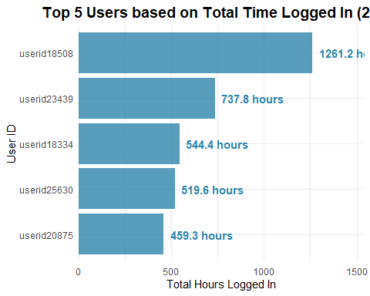

Part 2- Calculating Average CPU Usage for the top 5 users
As we have mentioned in our data preparation section, the CPU usage data has negative values that question the credibility of the data. So for the top 5 users we calculated the average CPU usage twice, once with the data that we were provided with including the negative values and then another one by getting rid of the negative values and only using the positive values. I also provided a bar chart for visual representation that highlights the CPU usage for the users as well as the difference in results for calculating CPU usage using both approaches.
# Getting the top 5 user IDs from our previous results
top_5_users <- user_time$userid
# CPU usage with ALL data (including negative values)
cpu_all_data <- usage_2015_vdi %>%
filter(userid %in% top_5_users) %>%
group_by(userid) %>%
summarise(
avg_cpu_all = round(mean(avg_cpu, na.rm = TRUE), 1),
total_cpu_records = n(),
negative_cpu_records = sum(avg_cpu < 0, na.rm = TRUE),
negative_cpu_percent = round(sum(avg_cpu < 0, na.rm = TRUE) / n() * 100, 1)
)
print(cpu_all_data)
## # A tibble: 5 × 5
## userid avg_cpu_all total_cpu_records negative_cpu_records negative_cpu_percent
## <chr> <dbl> <int> <int> <dbl>
## 1 useri… 4.1 644 147 22.8
## 2 useri… 4.3 1235 444 36
## 3 useri… 4.6 812 304 37.4
## 4 useri… 16.4 1016 48 4.7
## 5 useri… 5.7 916 17 1.9
# CPU usage with ONLY POSITIVE values
cpu_positive_only <- usage_2015_vdi %>%
filter(userid %in% top_5_users, avg_cpu >= 0) %>%
group_by(userid) %>%
summarise(
avg_cpu_positive = round(mean(avg_cpu, na.rm = TRUE), 1),
positive_cpu_records = n()
)
print(cpu_positive_only)
## # A tibble: 5 × 3
## userid avg_cpu_positive positive_cpu_records
## <chr> <dbl> <int>
## 1 userid18334 7.9 497
## 2 userid18508 10.6 791
## 3 userid20875 9.6 508
## 4 userid23439 17.5 968
## 5 userid25630 5.8 899
# Combine all results
final_cpu_analysis <- user_time %>%
left_join(cpu_all_data, by = "userid") %>%
left_join(cpu_positive_only, by = "userid") %>%
select(userid, total_hours_logged, total_sessions, total_cpu_records, positive_cpu_records, negative_cpu_records, negative_cpu_percent, avg_cpu_all, avg_cpu_positive)
print(final_cpu_analysis)
## # A tibble: 5 × 9
## userid total_hours_logged total_sessions total_cpu_records
## <chr> <dbl> <int> <int>
## 1 userid18508 1261. 271 1235
## 2 userid23439 738. 176 1016
## 3 userid18334 544. 128 644
## 4 userid25630 520. 251 916
## 5 userid20875 459. 167 812
## # ℹ 5 more variables: positive_cpu_records <int>, negative_cpu_records <int>,
## # negative_cpu_percent <dbl>, avg_cpu_all <dbl>, avg_cpu_positive <dbl>
# Preparing data for visualization
cpu_comparison <- final_cpu_analysis %>%
select(userid, avg_cpu_all, avg_cpu_positive, negative_cpu_percent) %>%
pivot_longer(cols = c(avg_cpu_all, avg_cpu_positive),
names_to = "calculation_method",
values_to = "cpu_usage") %>%
mutate(
calculation_method = ifelse(calculation_method == "avg_cpu_all",
"With Negative Values",
"Positive Values Only")
)
# Creating custom x-axis labels with percentage of negative entries
custom_labels <- final_cpu_analysis %>%
mutate(
custom_label = paste0(userid, "\n(", negative_cpu_percent, "% negative)")
) %>%
pull(custom_label)
names(custom_labels) <- final_cpu_analysis$userid
# Creating the comparison visualization
ggplot(cpu_comparison, aes(x = userid, y = cpu_usage, fill = calculation_method)) +
geom_col(position = "dodge", alpha = 0.8) +
geom_text(aes(label = paste0(cpu_usage, "%"),
y = cpu_usage + 2),
position = position_dodge(width = 0.9),
size = 3.5, fontface = "bold") +
labs(
title = "Comparison of CPU calculations with and without negative values",
x = "User ID",
y = "Average CPU Usage (%)",
fill = "Calculation Method",
) +
scale_fill_manual(values = c("With Negative Values" = "#A23B72", "Positive Values Only" = "#2E86AB")) +
scale_x_discrete(labels = custom_labels) + # Use custom labels with negative percentages
theme_minimal() +
theme(
plot.title = element_text(face = "bold", size = 14, hjust = 0.5),
plot.subtitle = element_text(color = "gray40", size = 11, hjust = 0.5),
plot.caption = element_text(size = 9),
legend.position = "top",
axis.text.x = element_text(color = "black", face = "bold", lineheight = 0.8)
) +
scale_y_continuous(limits = c(0, max(cpu_comparison$cpu_usage) + 10))
